CAPTOR Web Elements Naming Convention

This documentation aims to clarify some of the most common terms used across the UI/UX community in regards of UI elements used in HTML.

1. **Search Field** – Also commonly known as a “Look up”, this is a text field used to generate a search query from a database and it is activated by typing a search criteria and pressing enter.



1. **Dropdown Menu** - This is a dropdown box that often includes menu options. This is not to be confused with the **dropdown field** explained below. However, in CAPTOR, we are making use of this element’s flexibility to customize dropdown fields and avoid the Windows <select> field which produces a very generic look and feel.

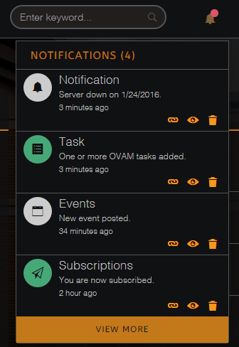 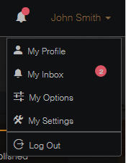

1. **User Menu** – See above*. Also referred to as the CIA (Center for Information Access). This is the menu reserved for the user to customize his preferences and settings. We will use the term ***User Menu*** from this point forward.
2. **User Name** – The user name is often shown in the header as the head of the user menu. It shows the user that he/she is logged in properly. This can be a name, username, or ID. See pic above*.
3. **Main Menu** – This is considered to be the main application navigational menu. In many websites this is often displayed horizontally within the header of the site. In CAPTOR, we are using a vertical sidebar menu concept. The Main Menu is ever-present regardless of page as long as the user is logged in.

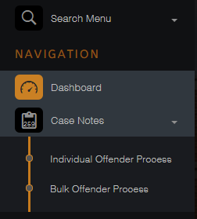

1. **Menu Item** – The main menu is comprised of menu items. These are the navigational links that initiate a navigational flow. See pic above*
2. **Sub-Menu** – In some cases, a menu item is not a navigational link, but a toggle to uncover a nested menu called *sub-menu*. The sub-menu is a broken down menu that includes more than one flow within a category group that is related to the menu item. For instance, if Case Notes includes several operation flows, it would include a sub-menu specifying how to initiate each flow independently. This is crucial to allow the user to enter these flows from any page without having to navigate back to the beginning. See pic above*
3. **Menu icon** – The menu icon is used to provide a visual representation of the flow or menu item. One of its most important uses includes the dropdown icon or down-caret icon. This icon conveys to the user that the menu item is in fact a sub-menu toggle and clicking on it will reflect a sub-menu instead of navigating away from the page. See pic above*
4. **Search Menu** – This search element provides the means to search through a menu that could potentially become extremely nested or complex. See pic above*
5. **Page Header** – Every page should include a page header to specify in which page the user currently is. If the page includes waypoints, the page header is consistent throughout the waypoints because the user has not navigated away from the page. The user is simply navigating through the waypoints instead. For consistency purposes, the page header also uses an icon, oftentimes, the same icon depicted in the menu item.



1. **Widget Box** – Some pages, such as the dashboard uses blocks or boxes. These boxes are called widgets and can be used very widely. They compartmentalize the screen without making it look messy. They are also very responsive and adopt a 100% width in devices with smaller widths.

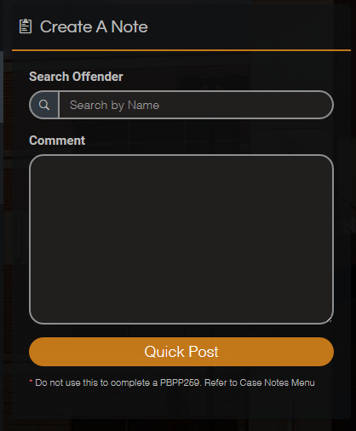

1. **Calendar** – The calendar is an element that is used to record and display events. In CAPTOR we are using the Bootstrap-Calendar. This is ***NOT*** an datepicker calendar.

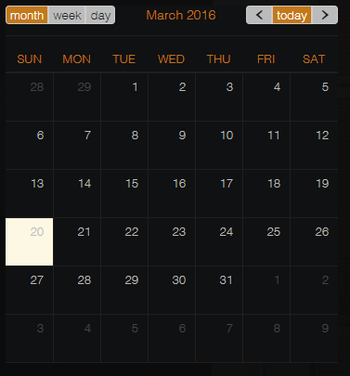

1. **List** – The list is a display view that separates items in a stacked fashion with a separating border. It compartmentalizes the items meanwhile grouping important information within them.

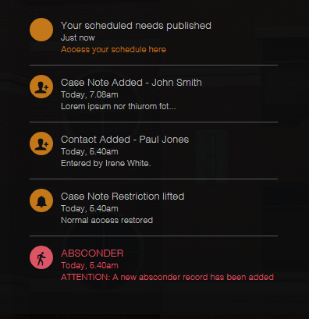

1. **Progress Bars** – The progress bars are widely used in UX to convey to the user a representation of measure. Some of the most popular uses are to show a completion rate or to show a percentage ratio.

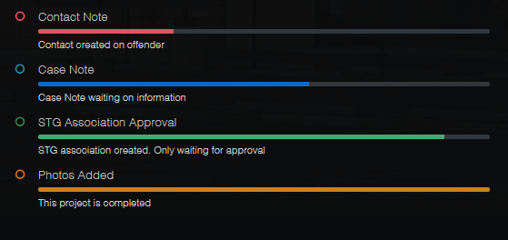

1. **Back to Top** – In some occasions, a page can display a long scroll. It is important to allow the user to quickly scroll to the top of the page in one single click and not have to scroll manually.



1. **Collapse Icons** – These particular icons let the user know when something is collapsible. It shows the direction in which it will collapse, and it changes to the opposite direction to show the user the item can be expanded.

 

1. **Widget Header** – The widget header specifies the content of the widget and it can provide a small description or guideline to the user.



1. **Section** – Oftentimes, the page will display more than one group or set of instructions. It is wise to divide these in sections with a section title. This compartmentation avoids run-ins and creates spatial differences that are beneficial to reducing cognitive friction.

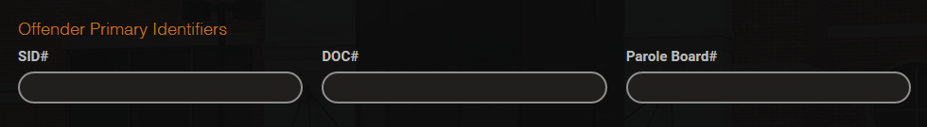

1. **Buttons** – There are several buttons used in CAPTOR for different purposes:
   1. **Default Button** – Always on the right side of the screen. It denotes positive action such as: Search, Next, Submit, Save, Enter, Send, etc. 
   2. **Secondary Button** – Always on the left side of the screen. It denotes negative action or a secondary flow from the page. i.e.: Clear, Back, Previous, Cancel, Leave, etc. 
   3. **Danger Button** – This is a very specific red button that makes it clear to the user that the action will have a major impact. i.e. : Delete 
   4. **Inner Button** – The inner button is not a page button. It is an action button for an element. Although it can lead to another page, it is not the button you would find at the bottom of the page. These buttons do not need an icon: 
2. **Label** – The label is used to identify an element. It can be used with form fields or it can also be used in lists.

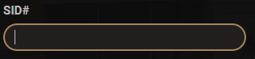 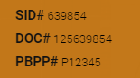

# Form Fields

1. **Text Field** – The text field takes a one-line string of text or numbers.



1. **Date Field** – The date field uses a date picker and its purpose is to represent data in date format. The icon denoting that is a date field is placed on the left of the field to separate it from the look and feel of a regular text field.



1. **Datepicker** – The datepicker is a custom script used to allow the user to select a date from a calendar and pass it to the date field. CAPTOR uses the Bootstrap datepicker. It offers much better functionality as well as a more customizable look and feel than the Windows generic datepicker. The datepicker can be placed to open to the top, left, right, or bottom.

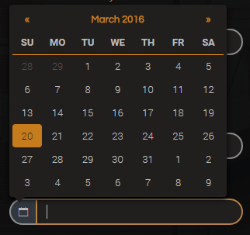

1. **Date Range Fields** – The date range fields are date fields with datepickers in each of them. They allow the user to select from a range of dates (min-date to max-date). The date range datepicker also offers timepicking as an option.



1. **Dropdown Field** – The dropdown field provides a dropdown with a selected number of options to choose from. The user can only choose one option.

 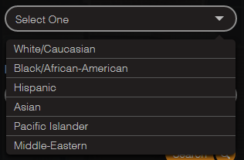

1. **Radio Button Group** – The radio button group is used to select form a set number of options. They have been customized to compliment the look and feel of CAPTOR instead of the Windows generic look and feel



1. **Checkbox Group** - The checkbox is used similar to the radio button group with the exception of multi-selection. They have been customized to compliment the look and feel of CAPTOR instead of the Windows generic look and feel.



1. **Rich Text Editors** – These are used to give the user the ability to format their text by having features such as bold/italics/underline. In CAPTOR we use TinyMCE as the RTE of choice due to its versatility

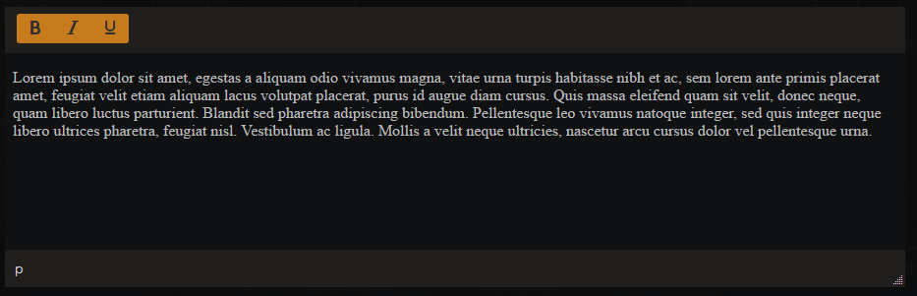

# Other Items

1. **Tabs** – Tabs are toggle elements used to separate information into views where only one is visible at any given time. This maximizes the amount of data used on the page without having to navigate away from the page to view it and at the same time, it avoids page clutter by making it invisible until clicked.

 

1. **Tiles** – The tiles are a terrific way to represent data that it would have normally needed a table to do it. Tiles are 100% responsive and customizable. Tiles in CAPTOR are also able to flip to display additional information by making use of its back-side.

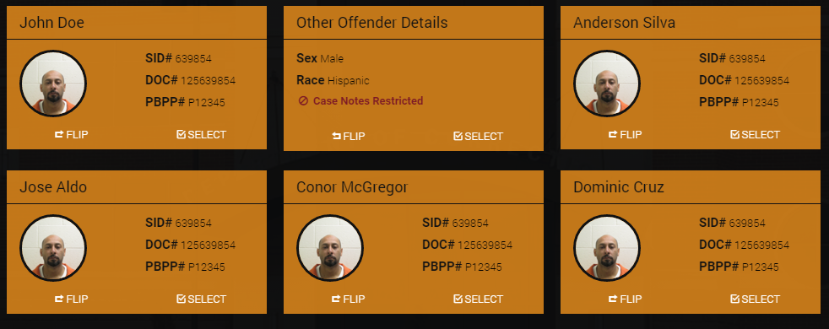

1. **Pagination** – Used to distribute a large amount of results into pages. In CAPTOR we use Bootstrap Paginator which it’s built in the framework.

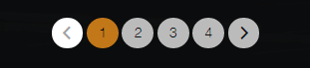

1. **Timeline** – A timeline is used to display chronological data in a more intuitive design.

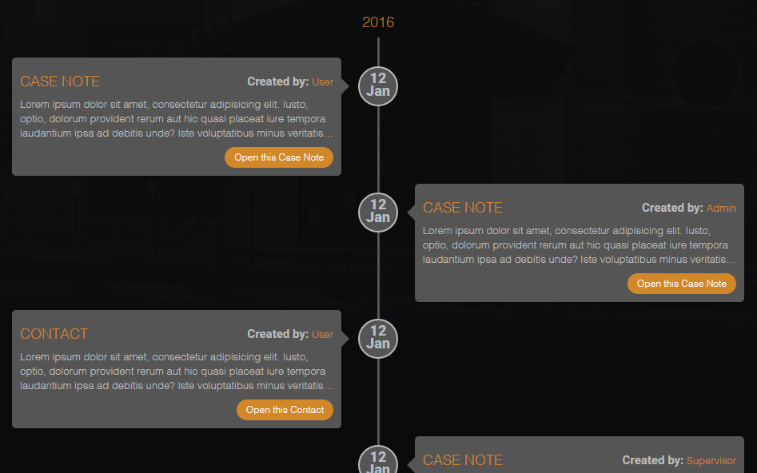

1. **Modal** – Modals are a revolutionized version of the old Windows popup. It is extremely customizable and easy to manipulate from HTML data-toggle, JQuery modal function, or from server side code. In CAPTOR we use modals to display confirmation messages or information in view mode. Modals are not recommended to be used whenever a postback is needed.

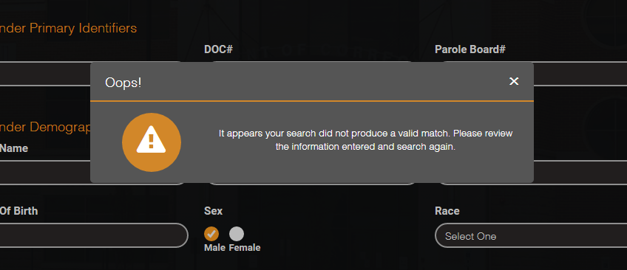

1. **Alert** – An alert is a floating box with a short time starvation. It is intended to capture the attention of the user without being extremely intrusive. Although they can accept HTML and action/event, it is recommended these are kept to a minimum. In CAPTOR we are using alerts as part of the notification system.

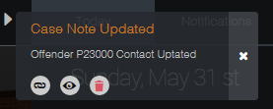

1. **Tooltip** – A tooltip is used to convey a small message while hovering an item. It is often used with a question mark icon to let the user know there is additional information relevant to the item. In CAPTOR we use Bootstrap tooltip on hover trigger.

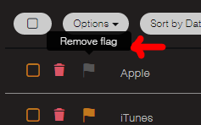

# Future Features

1. **Tag it** – Tag it is a very popular feature in latest UI concepts used primarily for multi-keyword searches, thus allowing search fields to be more versatile and functional.

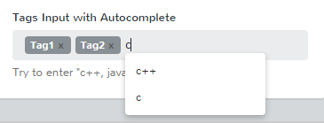

1. **jQuery Autocomplete** – Commonly found in search engines, autocomplete allows the user to narrow down the options as he/she searches for a specific keyword in a list. The list items must be existent in a database.

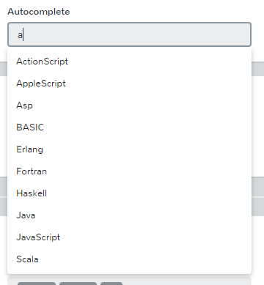

1. **Accordion** – The accordion’s purpose is very similar to the Tabs. For many UI/UX engineers it is a matter of preference or what makes more sense with the design they are working with. Accordions however serve a great role in collapsing menu items by grouping similar items in one accordion and open at will

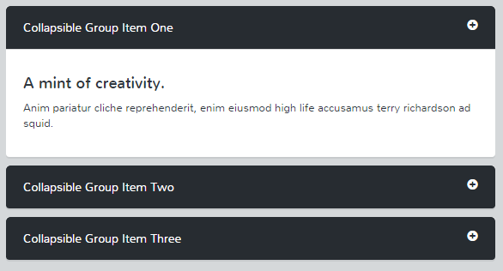

1. **Google Maps** - Google maps are an excellent feature to show locations in a map that is compatible with all Global Positioning Systems in mobile devices.

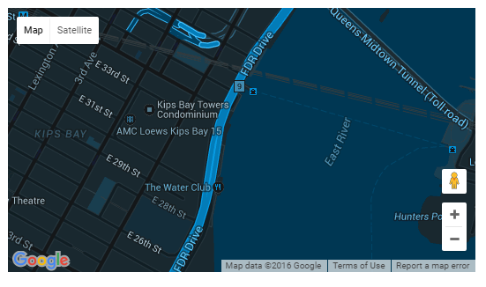

1. **Vector Maps** – In occasions, a vector map is an excellent tool when an interactive map is needed to show demographical data. For instance, showing SCI locations pinpointed in the Commonwealth and a map pin showing the amount of inmates in each location.

